COVID-19 vaccination
Altrincham Healthcare Alliance Primary Care Network which includes Altrincham Medical Practice, Park Medical Practice, Shay Lane Medical Centre (Drs Kelman, Cranston, Naylor, Pathak and Haslam) and St Johns Medical Centre is administering vaccines at Altrincham Health and Wellbeing Centre, 31-33 Market Street, Altrincham WA14 1PF.
Our GP practices are committed to delivering the COVID-19 vaccination to our patients.
Please be assured that we are working through the official priority groupings and will be in touch with you as supplies of the vaccine become available.
Please be patient as we often have short notice of the vaccine delivery. And please only attend the COVID-19 vaccination clinics if you have been contacted by your GP practice and have a confirmed appointment.
How to get to Altrincham Health and Wellbeing Centre:
The pedestrian entrance is on Market Street.
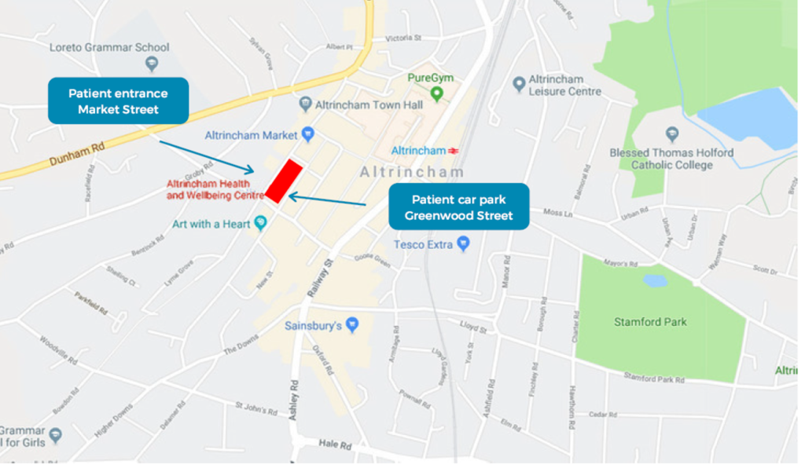
Car parking: the free underground car park can be accessed from Greenwood Street and is being made available to Blue Badge holders as a priority. A lift connects the car park to the medical centre on the first floor.
Car parking system at Greenwood Street: take a ticket to open the barrier to the car park. Follow the signs for patient/disabled parking. Access from the car park to St Johns Medical Centre is via stairs or lift (press ‘1’ for first floor). Following your appointment, your parking ticket will be date/time stamped at the GP reception. Make your way to the ground floor ‘welcome desk’ via stairs or lift (press ‘0’ for ground floor) where you need to exchange your stamped ticket with a validated exit ticket to operate the car park exit barrier.
Patients receiving the COVID-19 vaccination are also able to access free parking for up to one hour at the Stamford Quarter car park (M&S). Having obtained a coin token on entering the car park, this will need to be authorised after your appointment at the ground floor ‘welcome desk’ at Altrincham Health and Wellbeing Centre to enable your exit.
The British Red Cross is also on hand to assist those who may require transport to/from home. If you wish to use this service please contact 07912 080915.

Please remember:
- If you are unable to make the appointment, you will have to wait for a follow-up invitation
- There will unfortunately not be time for you to ask about prescriptions or other medical issues
- DO:
  - Bring your patient letter/proof of contact with you to your appointment
  - Wear a mask and respect the social distancing guidelines
  - Wear appropriate clothing to help the clinician administer the vaccination quickly
- DO NOT:
  - DO NOT attend the appointment if you have a temperature or feel unwell
  - DO NOT arrive early for your appointment
  - DO NOT drive immediately after your vaccination. All those who have the Pfizer vaccine will be asked to wait for 15 minutes before leaving the Health and Wellbeing Centre.

Our ‘walk through’ video:
One of the GP Partners at St Johns Medical Centre has created a ‘walk through’ video which may be useful to patients with confirmed appointments who are those unfamiliar with the venue.
For information regarding the COVID-19 Vaccination please visit www.nhs.uk/covid-vaccination
COVID-19 VACCINATION SCAM ALERT – JANUARY 2021
We have been made aware of a COVID vaccine scam which is targeting patients via email/text requesting banking details/payment for the vaccine.
Please be assured that the COVID-19 vaccine is free of charge on the NHS.
The NHS will contact you when it’s your turn to have the coronavirus (COVID-19) vaccination. We will contact you by letter, text or email with information on how to book your appointment.
The NHS will never ask for:
- your bank account or card details
- your pin or banking password
- copies of personal documents to prove your identity such as your passport, driving licence, bills or pay slips
If you think you have been a victim of fraud or identify theft, please report it to Action Fraud on 0300 123 2040.
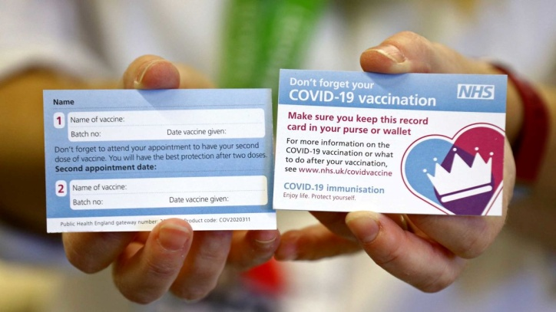
COVID-19 VACCINATION CARDS
We have had a number of enquiries regarding the importance of the COVID-19 vaccination card. We would like to reassure all our patients that these cards are not vital. If you have been vaccinated all the details are contained on your medical records.
Patients have contacted us regarding misplaced/lost cards and concerns that the card information is important. Please be assured that this is not the case. These cards are not proof of a vaccination – quite simply anyone could amend the written details if they wished – and do not contain secure, personal information.
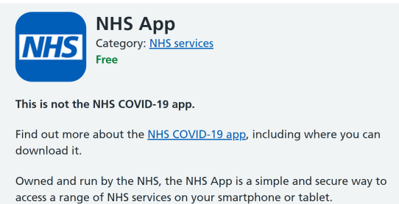
Any patient still wishing to receive a card when they attend their vaccine appointment will be given one, however for those who have lost or did not receive a card, it is not important.
You may wish to download the NHS App which enables you to access your records – including details of immunisations such as the Covid-19 vaccination – as well as providing health advice, allowing you to order prescriptions etc.

