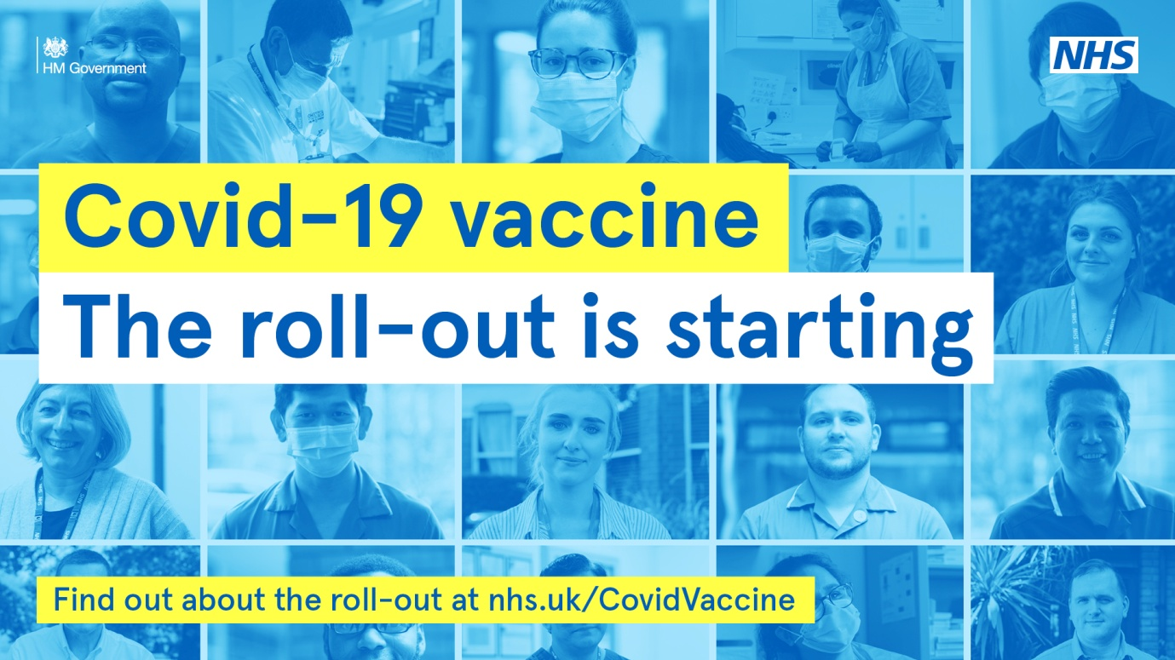

We are delighted to be the first GP practice network in Trafford to administer the COVID-19 vaccination to our patients.

Altrincham Healthcare Alliance Primary Care Network which includes Altrincham Medical Practice, Park Medical Practice, Shay Lane Medical Centre (Drs Kelman, Cranston, Naylor, Pathak and Haslam) and St Johns Medical Centre will be administering vaccines at Altrincham Health and Wellbeing Centre, 31-33 Market Street, Altrincham WA14 1PF on Wednesday and Thursday (16 and 17 December 2020)

How to get to Altrincham Health and Wellbeing Centre:
The pedestrian entrance is on Market Street.
Car parking: the free underground car park can be accessed from Greenwood Street and is being made available to Blue Badge holders only. A lift connects the car park to the medical centre on the first floor.

Car parking system at Greenwood Street: take a ticket to open the barrier to the car park. Follow the signs for patient/disabled parking. Access from the car park to St Johns Medical Centre is via stairs or lift (press ‘1’ for first floor). Following your appointment, your parking ticket will be date/time stamped at the GP reception. Make your way to the ground floor ‘welcome desk’ via stairs or lift (press ‘0’ for ground floor) where you need to exchange your stamped ticket with a validated exit ticket to operate the car park exit barrier.

Patients receiving the COVID-19 vaccination are also able to access free parking for up to one hour at the Stamford Quarter car park (M&S). Having obtained a coin token on entering the car park, this will need to be authorised after your appointment at the ground floor ‘welcome desk’ at Altrincham Health and Wellbeing Centre to enable your exit.

The British Red Cross are also on hand to assist those who may require transport to/from home. If you wish to use this service please contact 07912 080915.

Please remember:
- If you are unable to make the appointment, you will have to wait for a follow-up invitation
- There will unfortunately not be time for you to ask about prescriptions or other medical issues
- DO:
  - Bring your patient letter with you to your appointment
  - Wear a mask and respect the social distancing advice
  - Wear appropriate clothing to help the clinician administer the vaccination quickly
- DO NOT:
  - DO NOT attend the appointment if you have a temperature or feel unwell
  - DO NOT arrive early for your appointment
  - DO NOT drive immediately after your vaccination. Wait for 15 minutes.

Our ‘walk through’ video:
One of the GP Partners at St Johns Medical Centre has created a ‘walk through’ video which may be useful to all those who have received letters/text from their practice and confirmed appointments. Please visit tiny.cc/covidvaccinealtrincham

For further information regarding the COVID-19 Vaccination please visit www.nhs.uk/covid-vaccination

