TRAFFORD PRIMARY HEALTH & PRACTICES

Data Protection Act Summary Care Record – Appendix 4 to Annex M

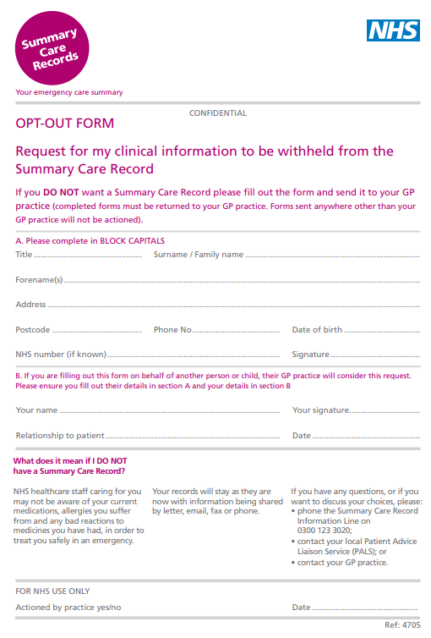
Creation date – 25th May 2018
Creator – Practice Manager
Deputy – Lead GP
Review – Two Yearly
Last Review – 31st January 2019

